
Your Invitation To An
AUTISM/PDD/ELL Workshop
at
CESA 3 Office
1300 Industrial Drive, Fennimore, WI
DATE: Thursday, October 20th • TIME: from 9 to 11 am
Check-in: 8:30 to 9 am
No cost to attend
Free 30 Day Trial Provided to Each Attendee

TOPIC: VISUAL LEARNING RESOURCES FOR AUTISM, PDD & ELL
Sponsored By Monarch Teaching Technologies & Vizzle® Software Program

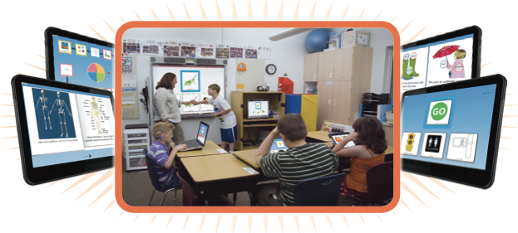

Please register at www.myQuickReg.com

For information on VizZle web-based Autism resources, contact:
ED KOWIESKI at 888-316-9193 or ekowieski@monarchtt.com

